# Helena Housing Authority Rent Café Landlord Portal User Guide

**Navigate to HHA Rent Cafe**

Using any browser and a connection to the internet, enter the URL address in the address field of [the browser, then press Enter on the keyboard.](https://www.youtube.com/watch?v=val_0Ab0er8) The URL Address for Rent Cafe is: https://portal.hhamt.org.

# Register for HHA Rent Café Landlord Portal

Once at website, at the top right of the web page click on the Landlord Login link.

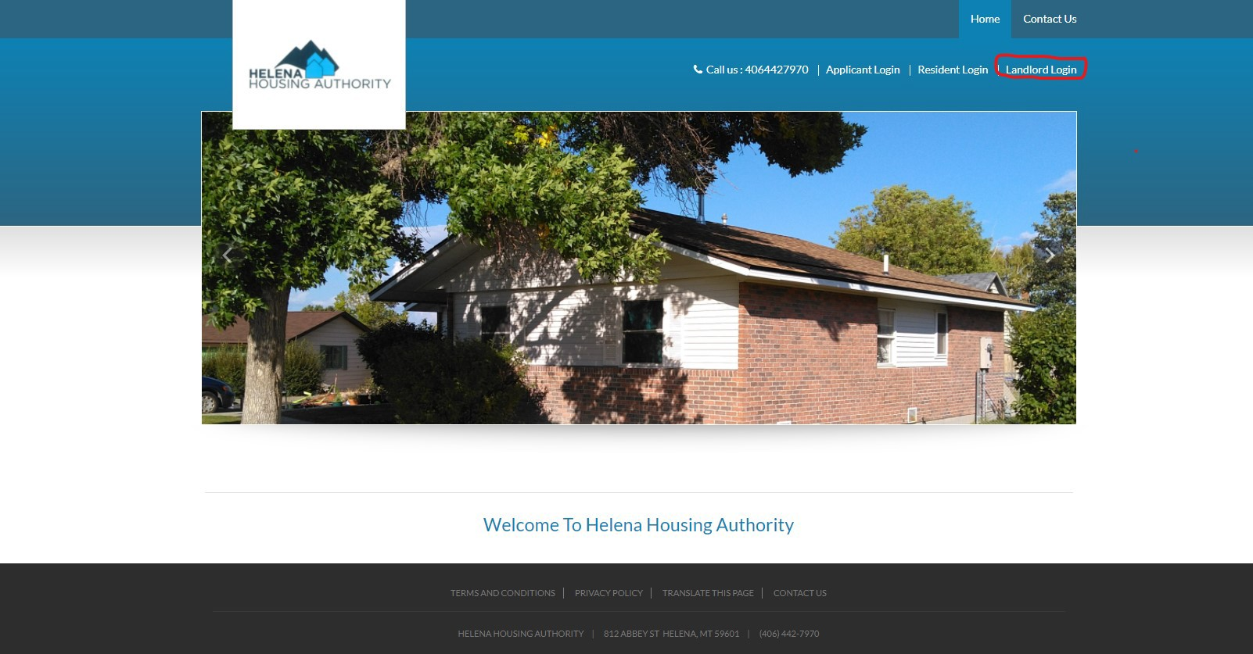

Next, click on “Click here to register” link.

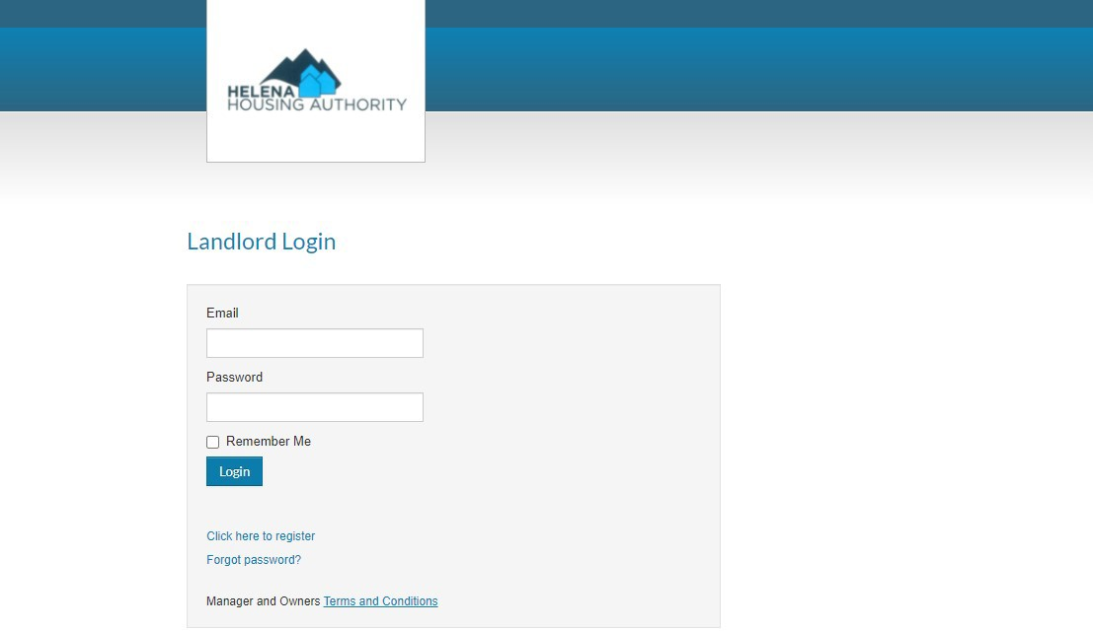

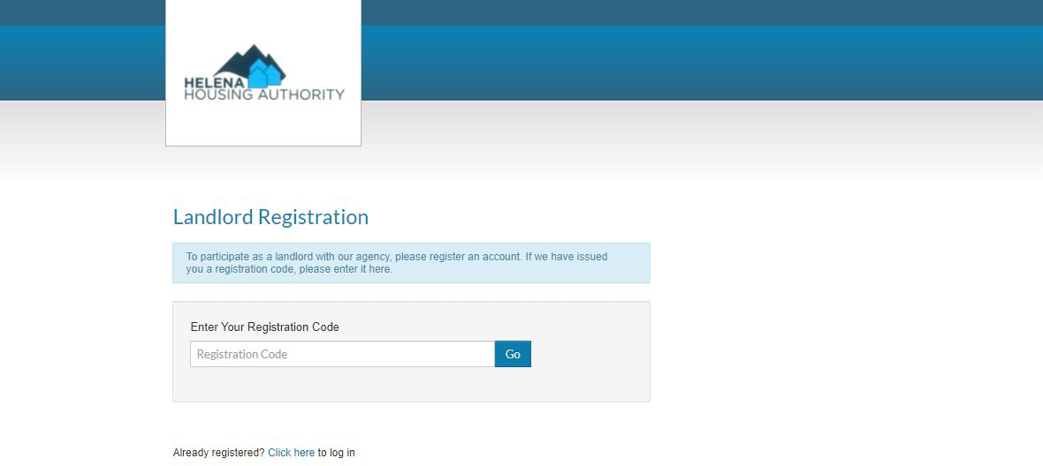Enter your registration code and click the Go button. The registration code will always be in the following format: This seven-character string, “**11208-L**” followed by your vendor code, for example, “**V0001234**” which is an 8-character code that starts with an V. For example, **11208- LV0001234**.

Next, enter in your Personal Information as outlined in the image below starting with your First Name.

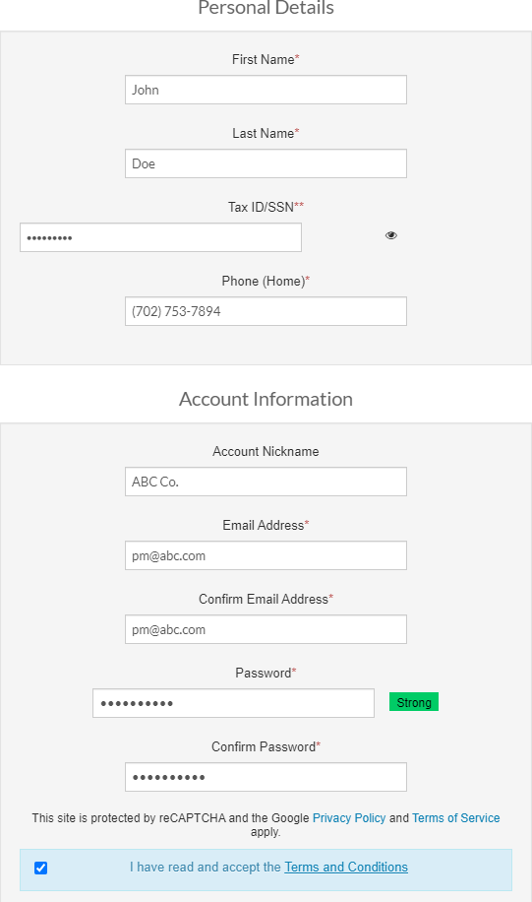

Next, click on the Register button to register.

# HHA Rent Café Landlord Portal Main Features

Next, if registering [is successful, you’ll](https://www.snvrha.org/docs/rentcafe/RentCafe-Landlord-Portal-Help.pdf) be redirected to the home page with the portal. The portal will have a main menu, tiles, and quick links to help you navigate throughout the portal.

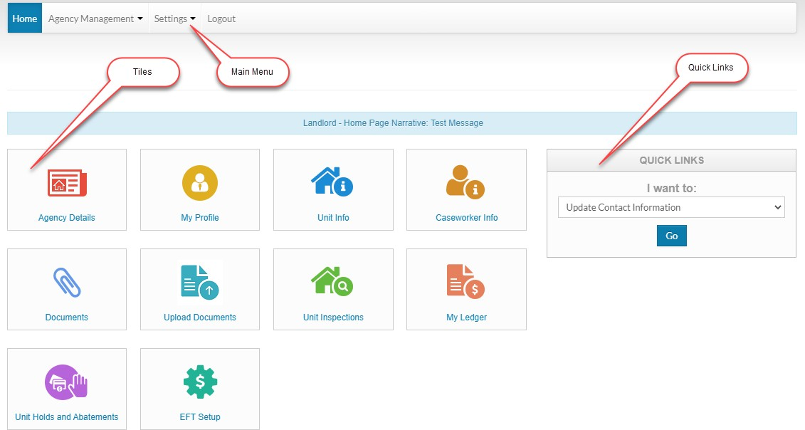

Click on the **Agency Details** tile to view details about your Housing Authority Agency, the Helena

Housing Authority. You will find contact information and even be able to email the agency.

Click on **My Profile** to edit your Rent Café Profile. You may update any of your profile information when you click on the My Profile tile.

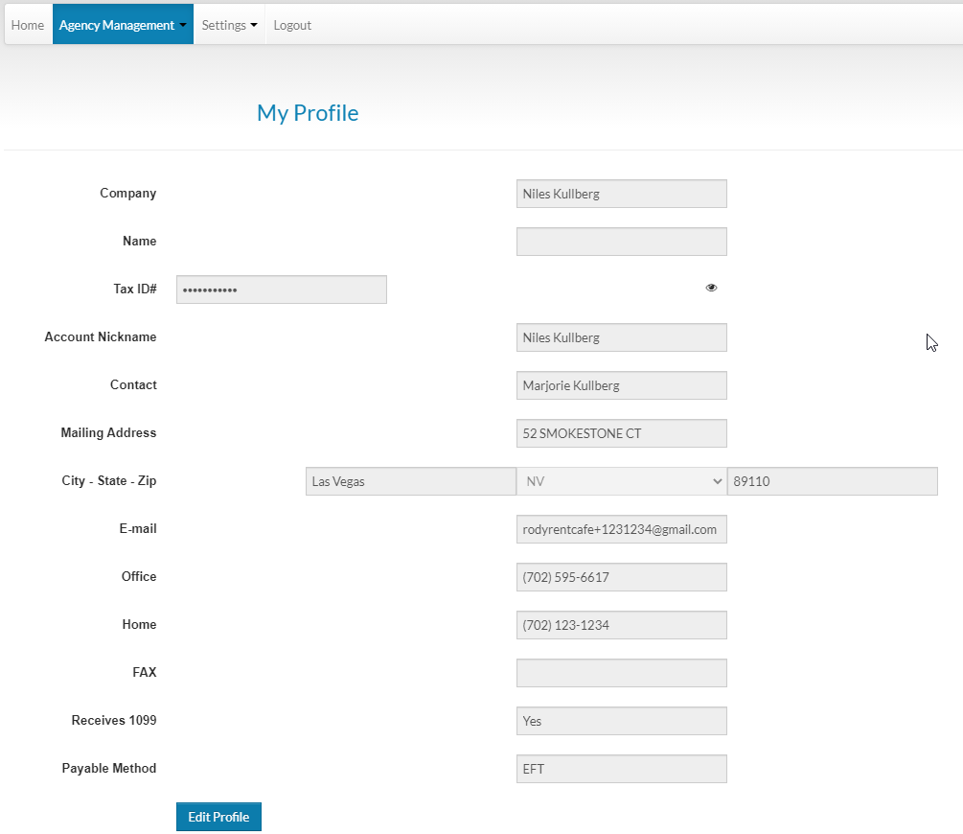

Click on the **Unit Info** tile to view your Unit information. You will be able to view the Unit Grid and filter by Number of Bedrooms and Unit Status. You will be able to do a text search to narrow your results and download to Excel.

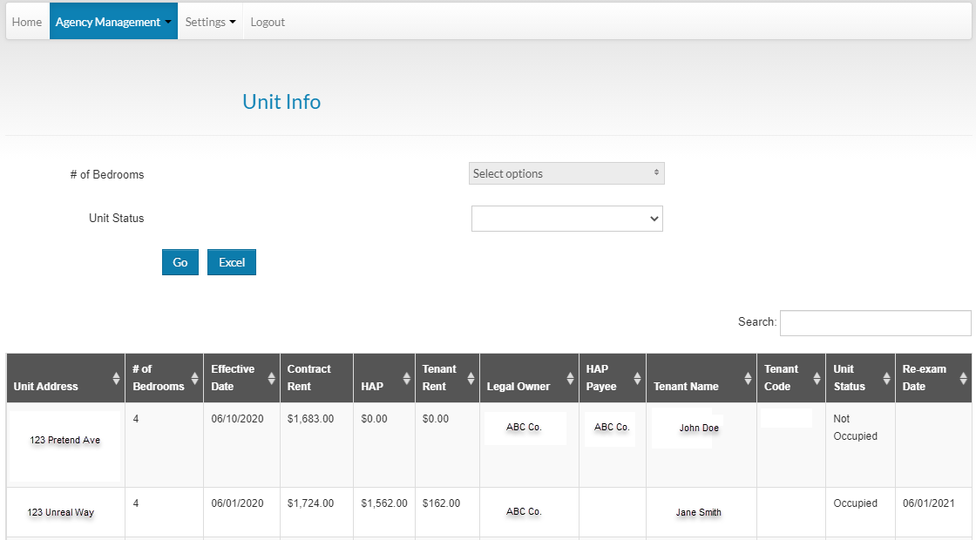

Click on **Caseworker Info** tile to view information about your caseworker.

Click on the **Documents** tile to view documents provided to you by HHA staff or even upload documents to the portal to be viewed by your caseworker.

The **Upload Documents** tile is the same as the Documents tile. It allows you to view documents provided to you by HHA staff or even upload documents to the portal to be viewed by your caseworker.

Click on the **Unit Inspections** tile to view your inspections. You can filter by Result Type and you can download to Excel.

Click on the **My Ledger** tile to view your ledger. You can filter by Period, check number or adjustment number. You have sorting options, text searching, and you can download to Excel.

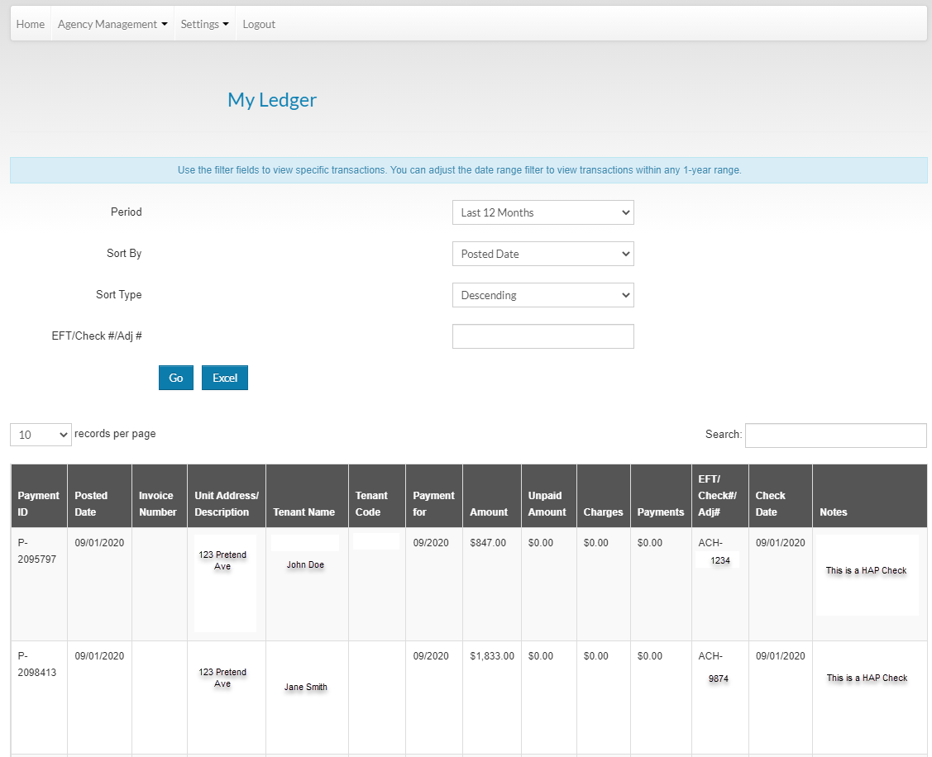

Click on the **Unit Holds and Abatements** tile to view holds and abatements on your units. You can view by scheduled date, you can do text searches and download to Excel.

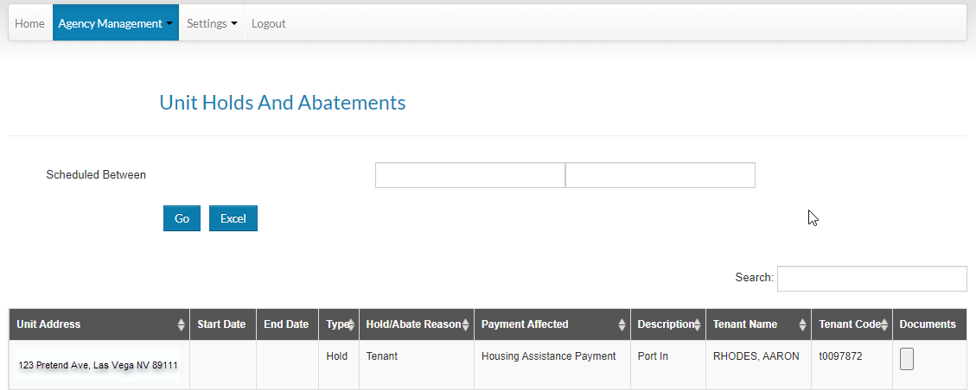

Click on the **EFT Setup** tile to edit your Electronic File Transfer setup.

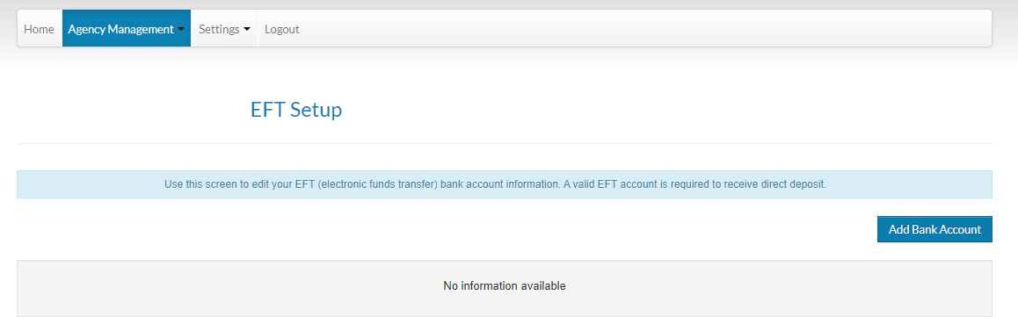

Click on the Add Bank button to add your banking information.

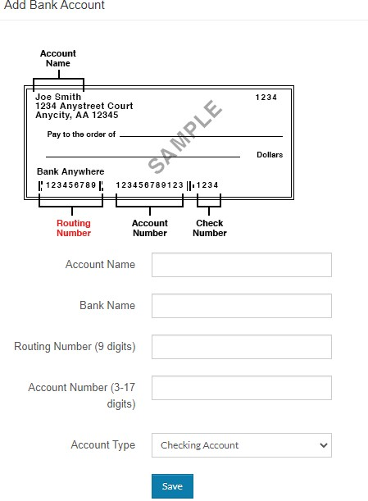

From the **Main Menu**, click on Settings, then **Change Email** to update your email address.

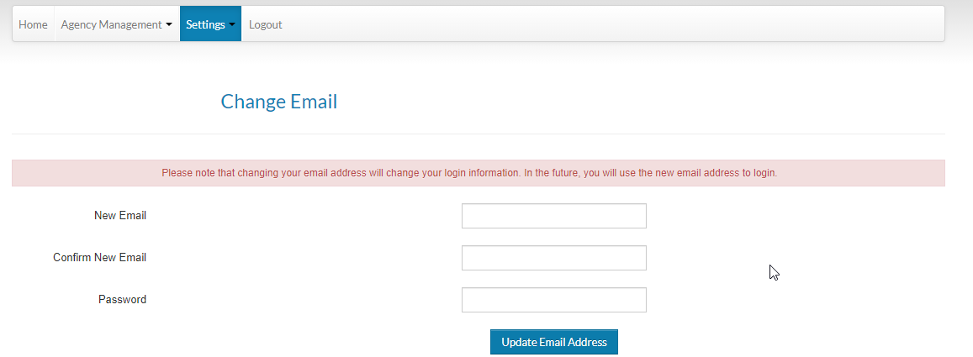

From the **Main Menu**, click on Settings, then **Change Password** to update your password.

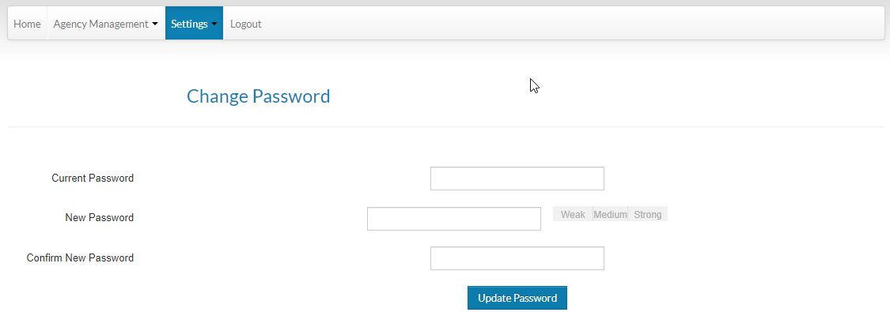

From the **Main Menu**, click on **Logout** to logout of Rent Cafe.